Save Our Shellfish and Coastal Economies from Ocean Acidification

Ocean acidification will be disastrous for Maine’s shellfish and economy. We must research, monitor, and plan to mitigate the damage before it is too late.

“We need to get on top of this now before our kids inherit this problem and it’s too late to fix it or adapt,”
-Dave Cousens, Maine Lobstermen’s Association.

Our oceans are becoming more acidic, and Maine needs to plan for the upcoming emergency

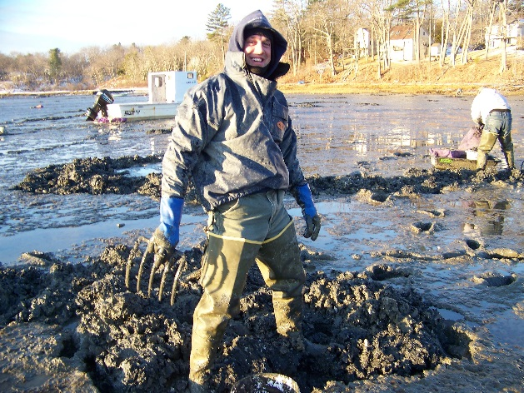
- Ocean waters off the coast of Maine have already experienced a nearly 30% increase in acidity.
- Maine’s juvenile clams are literally dissolving away, and larvae are avoiding the more acidic mudflats.
- Oyster hatcheries on the west coast have already experienced seasonal production losses of 60-80% due to acidification, and initial studies demonstrate that juvenile lobsters will develop thicker shells, and stunted growth.
- The main cause is that excess carbon dioxide (CO₂) in the air is being absorbed by oceans, but nutrient runoff along the coast is also contributing to the problem.

Over a billion dollars of economic activity and thousands of Maine jobs are at risk
- Maine is more dependent upon its marine resources than any other state in the northeast.
- Our top two fisheries (lobsters and clams) have nearly 6,000 active harvesters whose jobs are directly threatened, not even including sternmen and other industries.
- The Gulf of Maine waters have already been identified by researchers as being more susceptible to ocean acidification than other regions on the eastern seaboard.

We can protect our shellfish and coastal jobs, but we must start now
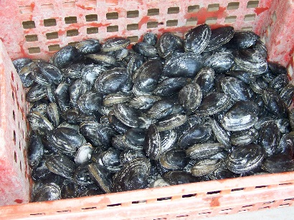
- There are many potential actions we can take to mitigate acidification: protect seagrass beds, reseed our clam-flats, reduce polluted runoff–but we must better understand the threat first before we will know what is best to do.
- LD 1602 helps us understand the threat. It takes a responsible and low cost approach to a major environmental crisis; it creates a panel of experts from all sectors of the marine community to study the problem and recommend solutions.
- If we better understand the impacts of acidification on commercially important marine species, coastal Maine communities can prepare before it is too late.

The Legislature should pass:
Resolve, Establishing the Commission To Study the Effects of Ocean Acidification and Its Potential Effects on Commercial Shellfish Harvested and Grown along the Maine Coast
For more information, please contact Ivy Frignoca, (207) 210-6439 x 5011 or ifrignoca@clf.org

